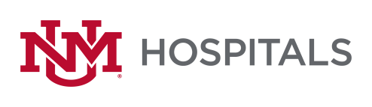

To: All Potential Offerors
From: Sherry L Tackett, Procurement Specialist
Date: 2/8/2023
Subject: RFP P470-22 Interventional Radiology Neuroendovascular Implants & Disposables
Addendum #4
Please add this Addendum #4 to the original RFP documents. It shall be the responsibility of the interested Offerors to adhere to any changes or revision to the RFP as identified in this Addendum.

The following clarification shall become permanent and made part of the procurement file.
- Section III - Vizient - We have a Sole source Neuro agreement w/Vizient (MS1431) can we leverage those T&Cs? No
- Categories - Can you verify these are all the categories being included?
  - Neuro Embolization
  - Aspiration Catheters
  - Stent Retrievers
  - Micro/Intermediate Catheters
  - Access Catheters
All items related to Neuroendovascular is being included.
- Rebates - In addition to aggressive line item pricing, do you also accept rebates? Yes How do you prefer them structured? That is up to you
- Cross Reference – Do you need a cross reference of products? No
- On Label - We assume you only want us to bid on-label products for ischemic stroke/mechanical thrombectomy/embolization. Please confirm. If this is what you sell for Neuroendovascular items, then yes.
- Decision Making - Can you share the roles that will be part of the decision-making committee? No
- Bidding Website – Is this active? Clicking the link took us to the homepage. http://hospitals.unm.edu/about/proposals.shtml
Please try below
https://unmhealth.org/about/bids-proposals/current.html

If there are any questions or inquiries in relation to this Addendum #4, Offerors may contact Sherry Tackett by email SLTaclett@salud.unm.edu

